2nd TCP Capture
This capture shows every major stage of a modern HTTPS connection: TCP handshake, TLS 1.3 handshake, Change Cipher Spec, and encrypted application data. We’re now seeing the entire secure-connection lifecycle in one view.
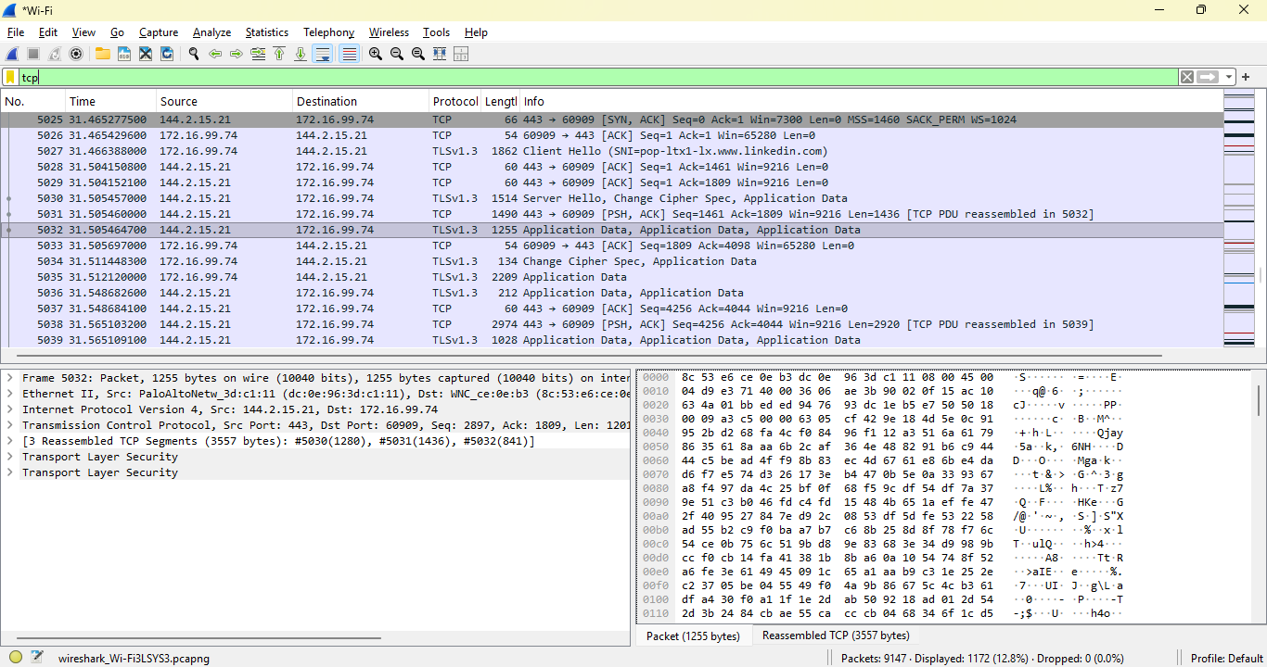
This capture shows a complete TCP + TLS 1.3 session between my host (172.16.**.**) and a remote server (144.2.15.21). The TCP handshake establishes the transport channel, followed by a TLS 1.3 handshake that negotiates encryption parameters. A Change Cipher Spec packet indicates the transition to encrypted communication. Subsequent packets contain TLS Application Data, representing encrypted HTTPS content. Although the payload is unreadable, metadata such as IP addresses, ports, packet sizes, and timing provide insight into the behavior of the secure session.
The important takeaway:
This capture shows our device (172.16.**.**) establishing a TCP connection to a remote server (144.2.15.21) on port 443, performing a TLS 1.3 handshake, switching to encrypted mode, and then exchanging TLS Application Data. It’s a complete secure session.
What the capture shows — step by step
1️⃣ TCP Handshake (SYN → SYN/ACK → ACK)
We can see packets like:
- [SYN]
- [SYN, ACK]
- [ACK]
This is the foundational transport layer setup:
- Our machine opens a connection using a random ephemeral port (e.g., 60989).
- The server responds from port 443.
- TCP establishes a reliable channel.
This is the “delivery truck” that TLS will ride inside.
2️⃣ TLS 1.3 Handshake Begins
We’ll see early packets labeled:
- ClientHello
- ServerHello
- Change Cipher Spec (rare in TLS 1.3 but still appears for compatibility)
TLS 1.3 encrypts most of the handshake, but Wireshark still identifies:
- Cipher suite negotiation
- Key exchange
- Session establishment
This is where the “locked box” (TLS) is placed inside the TCP “truck.”
3️⃣ Change Cipher Spec
This packet is visible in our capture.
In TLS 1.3:
- It’s not strictly required
- But some servers send it for backward compatibility
- It signals the transition from plaintext handshake to encrypted traffic
This is the moment the connection switches from “setup mode” to “secure mode.”
4️⃣ TLSv1.3 Application Data
This is the bulk of what we see:
- Large packets (hundreds or thousands of bytes)
- Marked as Application Data
- Fully encrypted
- Hex pane looks like random bytes
This is the actual HTTPS content:
- Web pages
- API responses
- Authentication tokens
- JSON
- Images
- Anything sent over HTTPS
We cannot read it without the session keys — but we can analyze:
- Size
- Timing
- Direction
- Frequency
- Server identity
- Behavior patterns
This is exactly what we SOC analysts do.
⭐ What this tells us about the server
The remote server is:
- 144.2.15.21
- Using TLS 1.3
- Responding with large encrypted payloads
- Likely a cloud or CDN endpoint (based on IP block behavior)
We can investigate further using:
- ip.addr == 144.2.15.21
- tls.handshake
- tcp.stream

